**Graphical User Interfaces**

Coursework Submission 2016

Deliverable Number: **2**

Group Name: **Omega**

Group Number: **31**

Group members:  
Name: **Prarthana Prakash** QM Email: **p.prakash@se13.qmul.ac.uk**  
Name: **Amir Moosa**  QM Email: **a.moosa@se14.qmul.ac.uk**  
Name: **Abbas Merali**  QM Email: **a.merali@se14.qmul.ac.uk**  
Name: **Hanifa Aziz**  QM Email: **h.aziz@se14.qmul.ac.uk**

**Requirements and Design Report**

* **Project introduction 3**
* **Description of users 3**
* **Matrix table (Primary Stakeholders) 6**
* **Techniques for data collection 7**
* **Task models 17**
* **Evaluation of existing weather applications 18**
* **Design 20**
* **Bibliography 26**

**Project Introduction**

In this project we have designed two weather applications to support each primary stakeholder that we have identified.

Our first application ‘Under the Weather’ supports commuters that are travelling within London using TFL services.

Our second application ‘Go Weather!’ is tailored towards outdoor event goers, specifically those that attend sport games, festivals, etc.

To produce a well created system we used the CUSTOM methodology for socio-technical techniques to gather our functional & non-functional requirements for our users.

In total we have created 4 designs, 2 for each primary stakeholder and each stakeholder has a smartphone screen(320x480) and a tablet screen(1024x768) design.

**Description of Users**

To decide our various stakeholders, we examined what was missing from existing weather applications and which users would benefit from when we create an application tailored to our stakeholders.

**Primary**

* Public transport commuters

**Background:** The users will be people that make their journey using TFL services for in particular work or school. They will require information that is relatively up to date and also easy to access for their journey so they can plan ahead.

**Experience:** The userswill have used a weather app before. So they will be familiar with our interface and have similar expectations. The application will be simple to navigate and easy to use. The user will have no problem working out the features we have added as they will be clearly label or easy to understand their functionality.

**Tasks:** The user will first need to specify their current location & their destination which the user can view in split screen. Then the split screen will appear showing the weather in both locations by clicking on either location will expand to give more information on that location. The expanded screen will be able to navigate to other options such as favourite locations tab where the user is able to add their most visited locations. They can also navigate to the tube status section where they are able to view whether their lines are running well.

* Event goers

**Background:** The users will be people who go to events such as festivals, sports games and shows. The users will be young or middle aged and be able to use applications with simple UI’s. They will require information which is up to date and be alerted of any drastic changes in the weather.

**Experience:** The user will easily be able to use our simple and easy to use GUI which we will create. They will be able to search the weather by hour and get information which is current and up to date. The user will get access to information about weather by searching events that they are attending.

**Tasks:** The user will need to specify their location of interest, then the weather of that location will be displayed. They can also search the location by events which are happening. The app will automatically show the location and weather based on event. You can also add the location to the ‘saved events’ feature 10 days before event and it will be displayed on the day of event.

**Secondary**

* Yahoo

The weather data for our application will be retrieved from Yahoo.

* Event organisers

They will benefit from our application as it will provide information about the event and also inform them about drastic weather changes. They could become primary users of the application and plan ahead before events. For event organisers ones of their aims is usually to make a large profit.

They will benefit from promotion of their events through the applications if users search for a location and an event is happening close by.

**Tertiary**

* TFL

We will give commuters a status update of Transport for London services. The information will feed from TFL into our application providing information on the service status of the different tube lines. They will usually have clear and up to date information which is easily accessible.

They will gain from increased traffic on their website and promotion of their services which they provide. It will make their information more easily accessible and user will be more inclined to visit this section in or application with little effort required.

TFL will have to provide information such as which tube lines have a good service and which have delays.

* App store

From the success of our application on App Store they will benefit with more traffic of users and downloads.

**Facilitating**

* App designers

They are students in university studying Computer Science. They will be proficient in designing UI’S and have to be able to conduct surveys and interviews to design the application. App designers must create the application to appeal to stakeholders and find out which features may appeal to them.

They must be able to use photo editing software to create the designs of what the app should look like. They must carry out research of what usually goes into a weather app and be able to gather knowledge from multiple sources to gain insight into primary stakeholders.

The app designers will have the task of identifying the requirements which are important to produce an app which best suits our primary stakeholders. They should also design an application which flows seamlessly and has an easy to use GUI. They should conduct research in the form of questionnaires and interviews.

* Developers

They have experience with programming and follow what the designers have suggested and create the application and make it into something that runs well and is easy to use.

They should be able to program in java to a high level to be able to create and implement the application features.

Based on what the app designers have made the developers should use the features and requirements to program the application.

**Matrix (table) of primary CUSTOM stakeholders**

|  |  |  |
| --- | --- | --- |
| Primary stakeholders | Commuters | Event goers |
| Aims | -Ensure they can quickly access accurate weather information to prepare for commuting between locations | -Ensure they can quickly access accurate weather information about the event location |
| Source of satisfaction | -Being well prepared with accurate information for their commute  -Pleasure of using the interface | - Being well prepared with weather conditions for the event  -Pleasure of using the interface |
| Knowledge and skills | -Knowledge of locations commuting to and from  -Knowledge of using a smartphone or tablet  -Knowledge of navigating around an application  -Skills to access Wi-Fi or mobile data | - Knowledge of event locations  -Knowledge of using a smartphone or tablet  -Knowledge of navigating around an application  - Skills to access Wi-Fi or mobile data |
| Attitudes to work | -Enthusiastic and motivated to use the weather application | - Enthusiastic and motivated to use the weather application |
| Work-group attributes | -They want quick access to up-to-date weather information on the go | They want quick access to weather information regularly e.g. hourly |
| Nature of activities | -Tapping the screen  -Swiping left and right | -Tapping the screen  -Swiping left and right |
| Responsibility | -Own a smartphone or tablet  -To install the app | -Own a smartphone or tablet  -Install the application |
| Working conditions | -In an area where there is access to the internet | -In an area where there is access to the internet |

**Techniques for data collection**

In order to get a good understanding of our users and to capture the correct requirements we used a number of primary and secondary sources.  
We used a range of data collection techniques including online surveys, interviews and card sorting.  
We first created an online survey for each primary stakeholder group to get a general consensus from our audience about their usage of weather applications. We then interviewed potential users to get a more in depth understanding of what they would require.   
Lastly, we used the card sorting technique to collect further information by asking potential users to sort a list of features into groups based on importance.   
The combination of these techniques allowed us to get the specifics of what our primary stakeholders expect from an application targeted to them. As a secondary source of information we researched the existing market for weather applications and looked into user reviews to see what users like and dislike about current applications.

The Online Surveys  
Sending out an online survey for each primary stakeholder group allowed us to get information from a large amount of people in a short period of time. Overall we received 90 responses - 47 responses for commuters and 43 for event attendees.  
We were able to get the straight forward answers we required by asking closed questions with the use of simple checklists and multiple choice options.  
As this was done electronically we were easily able to analyse and display the data in the form of graphs and charts.   
  
Examining the data gave us a good idea of what specific questions and areas we should address in our interviews to get a more in depth knowledge of user requirements.

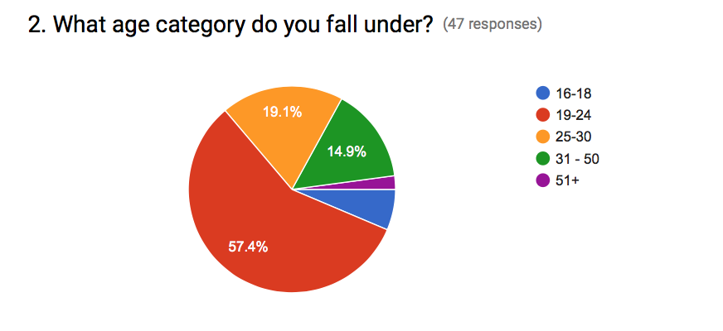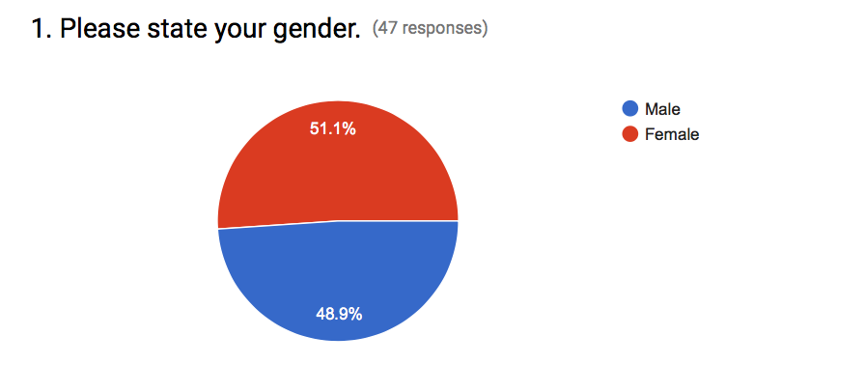**Results from online survey: Commuters**

From Q1 and Q2 we can see that we got a wide range of answers from both genders and a mixture of age groups, with the majority of people being 19-24.

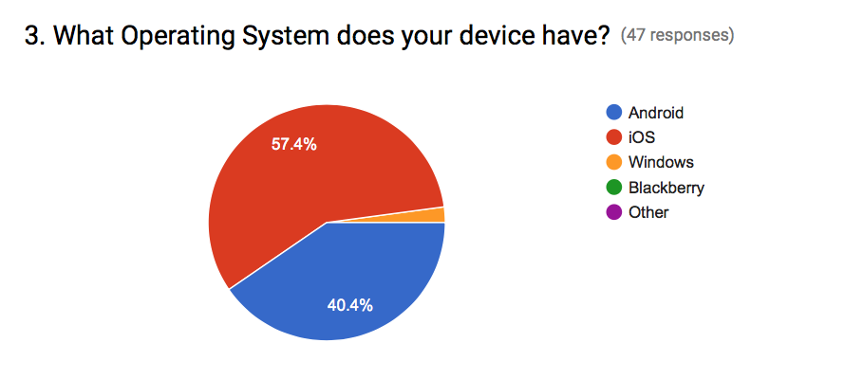

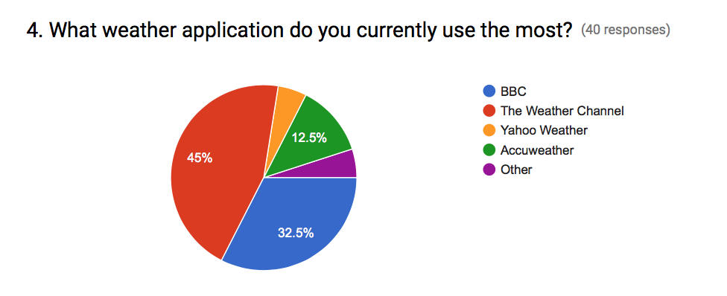

This figure shows that the majority of people asked use The Weather Channel(iOS weather) and BBC weather. We used this information to decide which existing weather apps to evaluate.

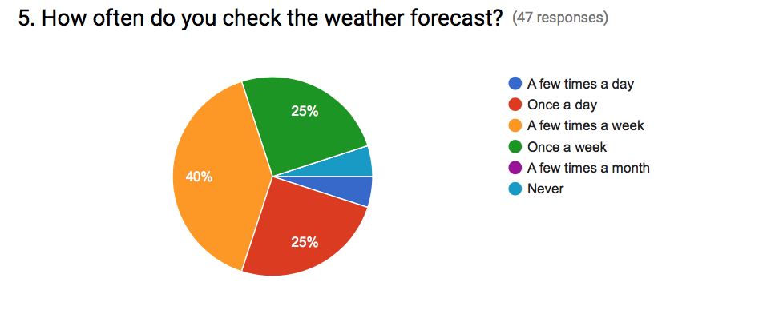

Most of the people we asked regularly check the weather forecast and therefore are potential users for our application.

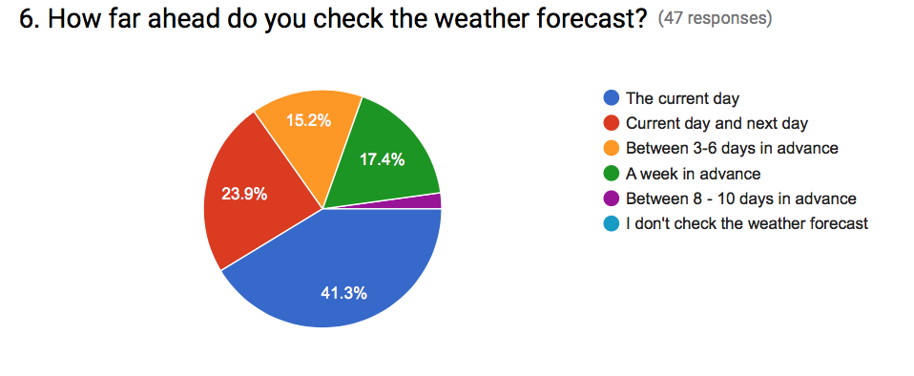

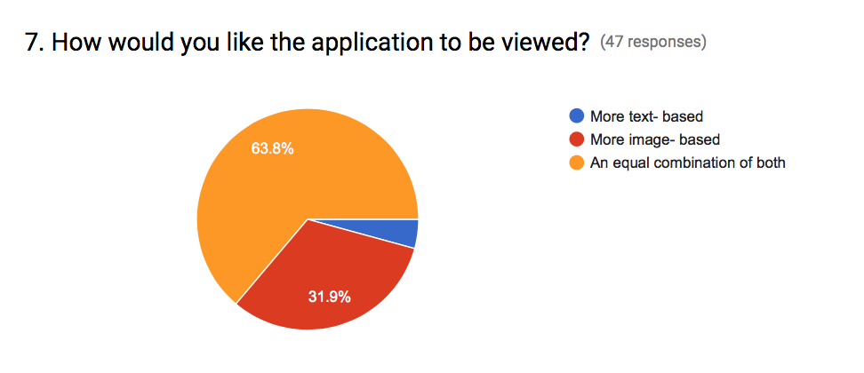

From this question we gathered that a very small percentage of people check the forecast between 8-10 days in advance.   
Most people check the forecast up to a week in advance therefore our application may benefit from a 7 day forecast with more focus on the current day

This figure shows that the majority of commuters (63.8%) prefer an interface that has an equal combination of text and images.   
The next highest percentage (31.9%) of people prefer a more image based-interface.

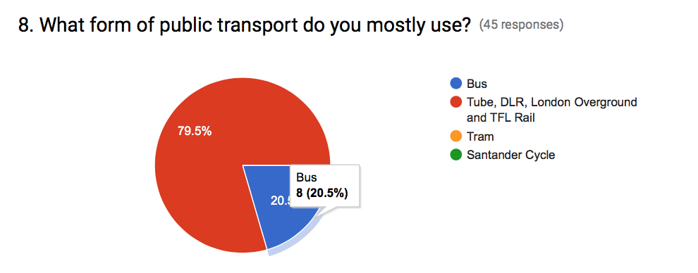

79.5% of people we asked use the tube service and could therefore potentially benefit from a tube service status feature.

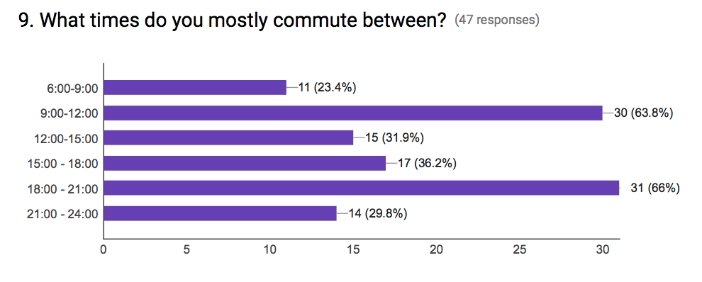

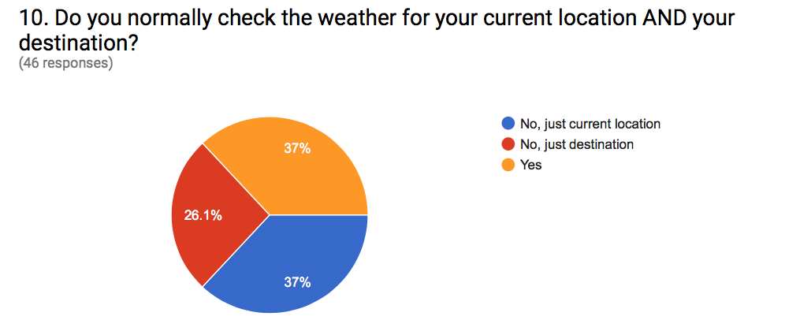

37% are interested in weather information about both current location and destination, and 37% are interested in weather information about the destination. Therefore, commuters may find it useful to have a split screen feature that displays information about both.

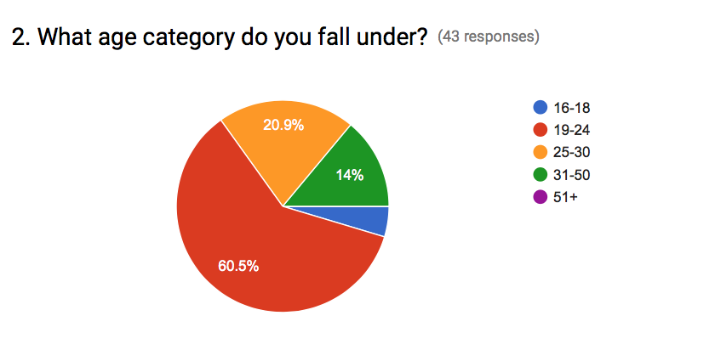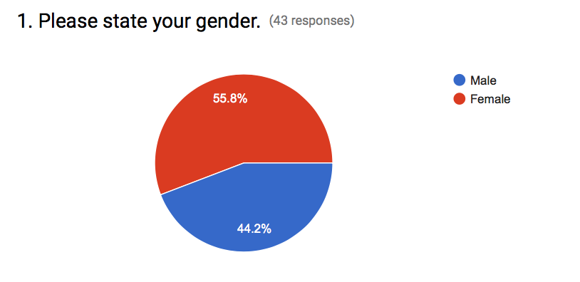**Results for online survey: Outdoor Event Goers**

From Q1 and Q2 we can see that we got a wide range of answers from both genders and a mixture of age groups, with the majority of people being 19-24.

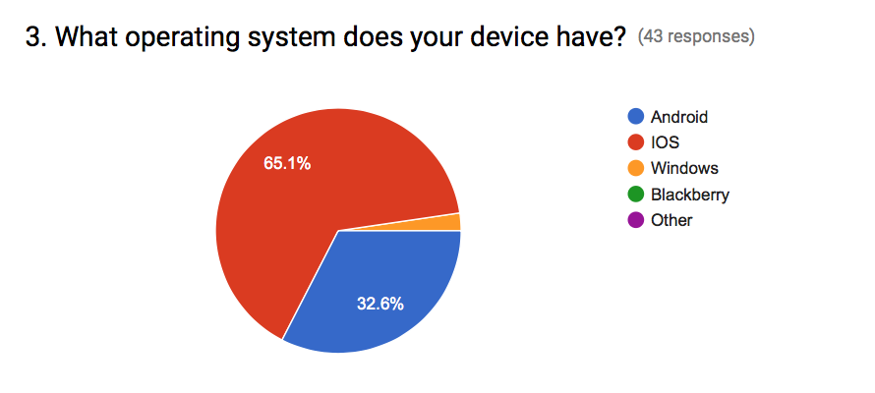

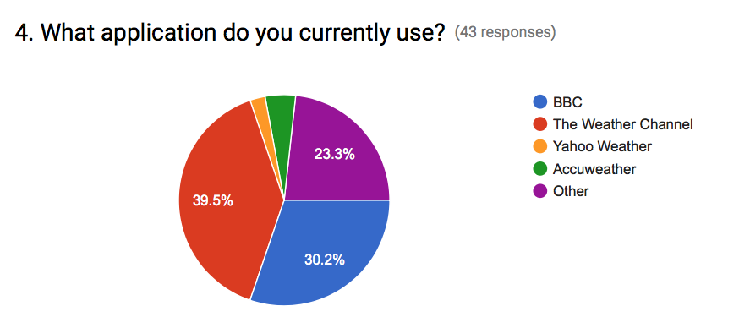

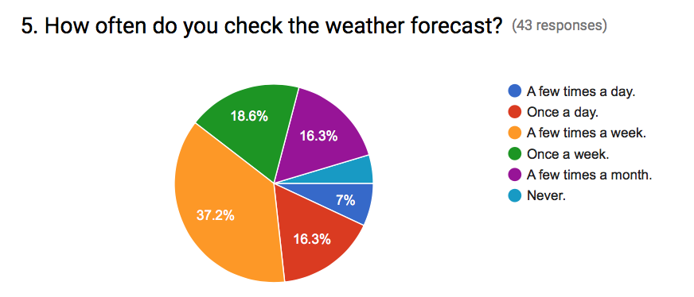

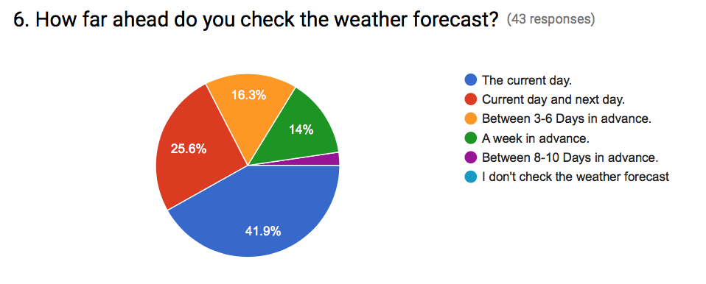

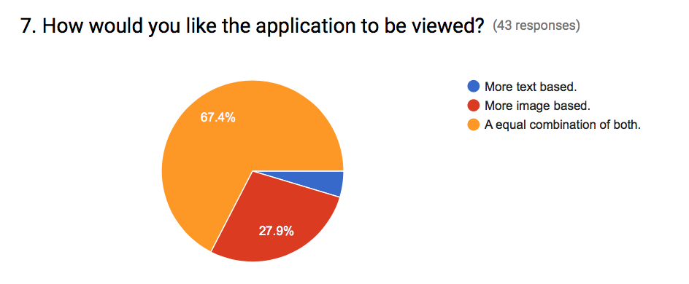

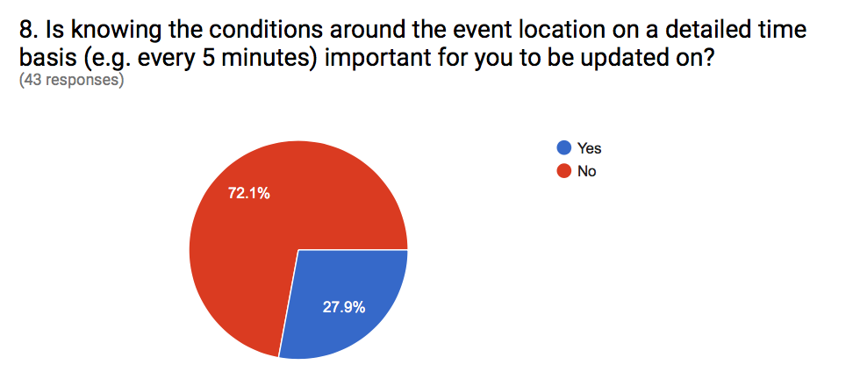

This shows that people do not require extremely up to date information.

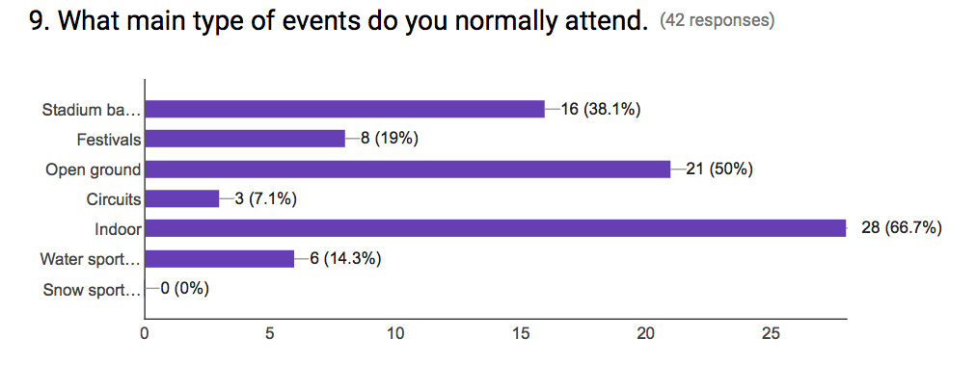

This shows that a lot of the people we asked are attenders of outdoor events.

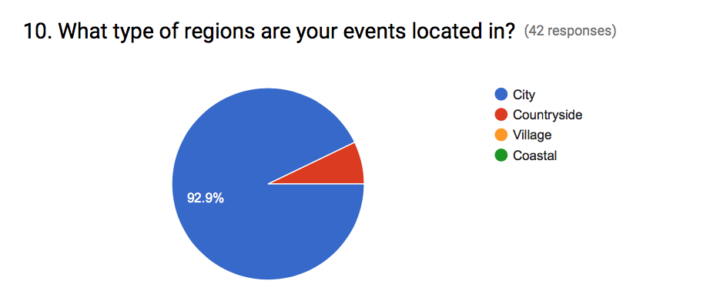

These results made us decide to target specifically people in London as more people attend events in cities.

**Interviews:**

To understand what would be beneficial in the weather application, we have interviewed 24 participants (12 from each stakeholder group). Each interview lasted approximately 15 minutes. We were able to ask open ended questions and follow up questions where necessary to gather a distinct set of requirements for each primary stakeholder group. The questions asked were used to help build on our knowledge from the online surveys and increase our understanding of crucial areas that are currently strong and weak within the existing weather application market.  
 We collected information on improvements and features that we could possibly include in the design and implementation of our application.

From close analysis of the interview answers, we have assessed concrete points that are valuable for our designs:

* The participants of both primary stakeholder groups have strongly stated that the main temperature for the day is clear and large so that it is easy to read.
* Commuters would like to see a basic interface that is easy to use with quick access to features.
* The majority of event goers would like to see more detail specific data about the weather such as wind speed, wind direction, humidity, and visibility. Whereas the majority of commuters would like simple information to be printed to the screen.
* The ability to customise the application is of interest to most of the interviewees from each stakeholder group.
* The operation for searching and viewing at least more than one location is important to both stakeholder groups.

A sample question from our interview was ‘At first glance, what would you like to see on the application?’. One answer for this question was “All I want is a simple interface which displays the temperature and forecast for the next few days”.

Another question is ‘What do you like and dislike about your current weather app?’. One response was “It is easy to use, scrolling the weather is relatively quick and never crashes”.

From the points evaluated above, using the interview process technique for gathering information has provided us an in depth perspective on what customers are potentially looking for. Obtaining information from the end users helps improve the accuracy to the weather application we wish to achieve for the end users.

**Card Sorting**

We used the card sorting method as a fun and interactive way of seeing which features our primary stakeholders value the most. We asked 12 Individuals from each stakeholder group to sort cards with specific features written on them into four categories: very important, important, not sure and not important.   
 We analysed the data by creating tables which allowed us to easily see which features we should prioritise when designing the different applications.

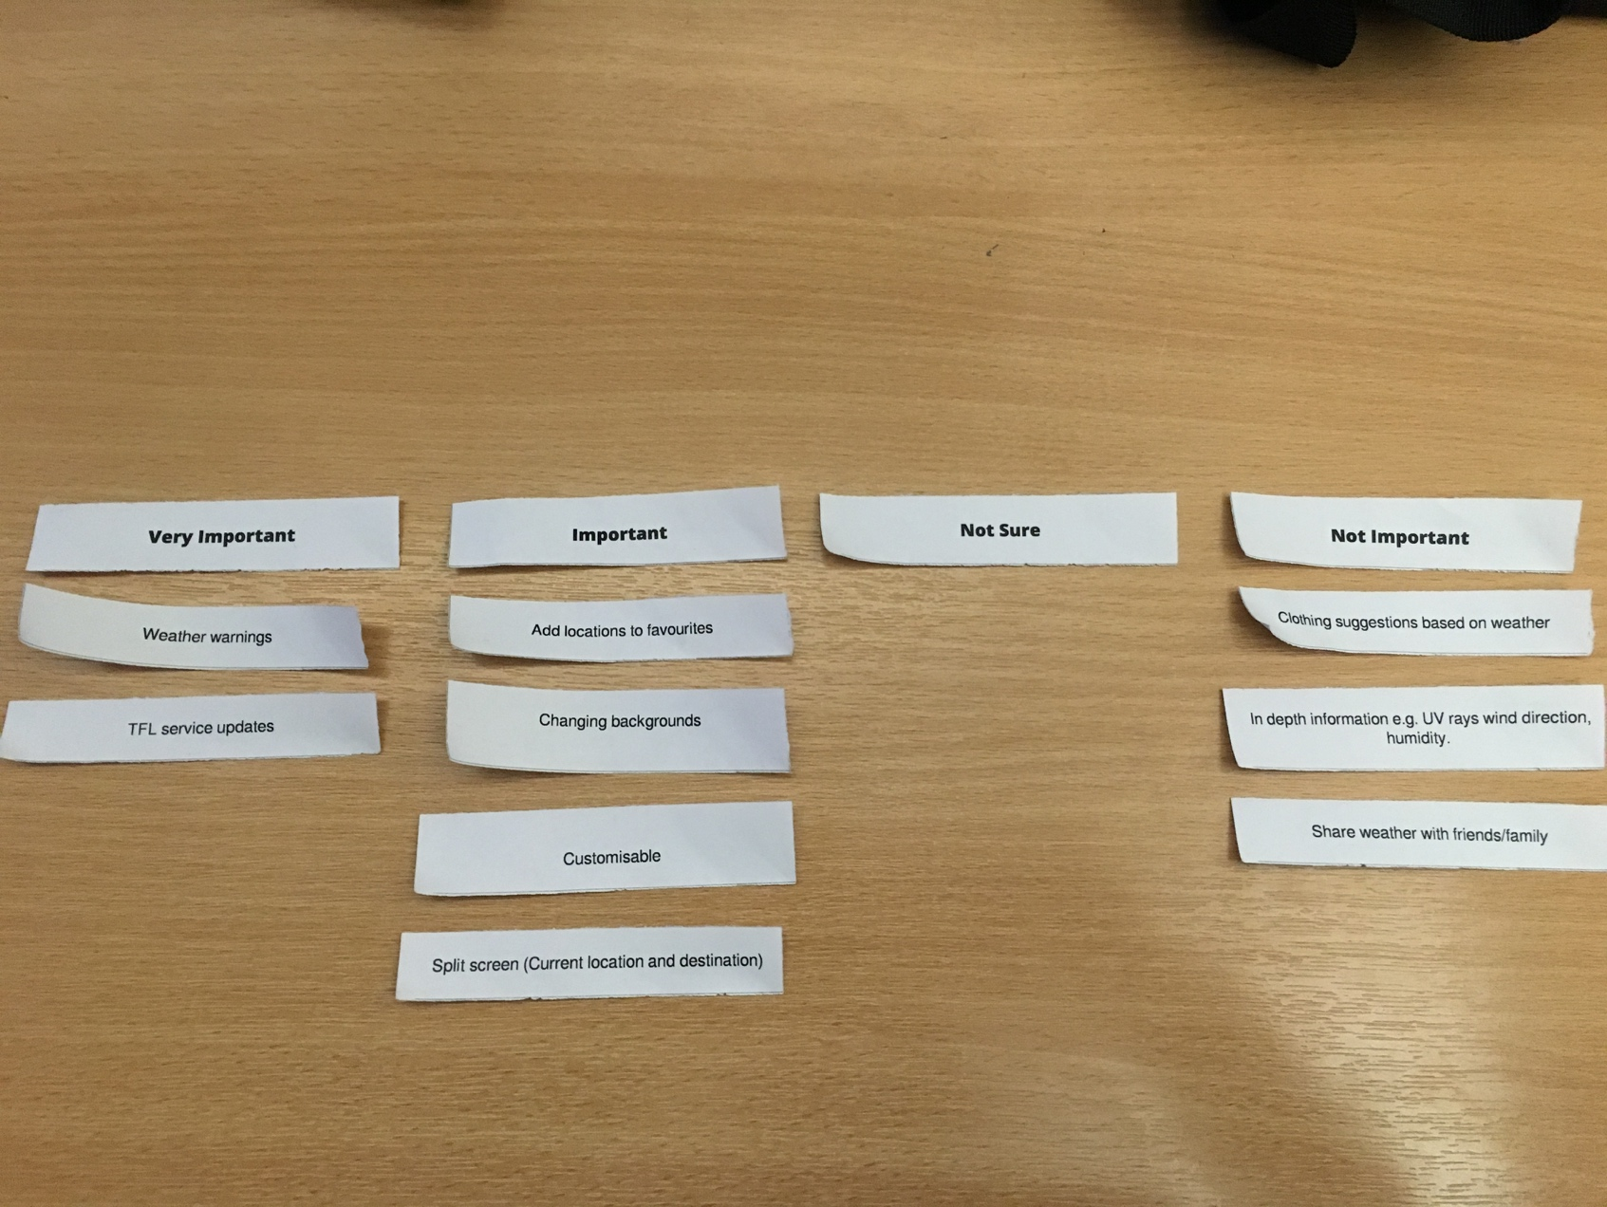

*****Example from our card sorting activity*

**Card Sorting Results**

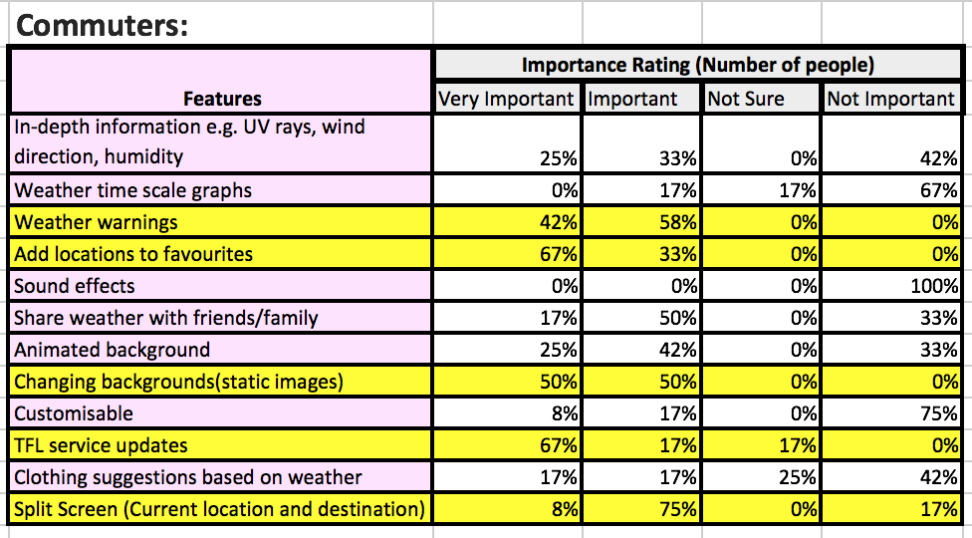The following tables show the results from our card sorting activity, with the most important features highlighted yellow.

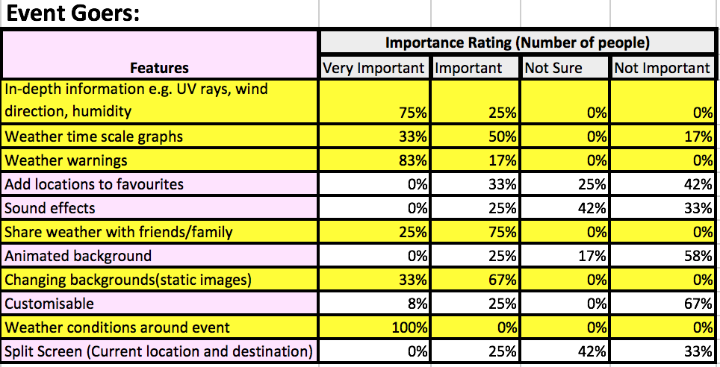

**Task Models**

**Commuters:**

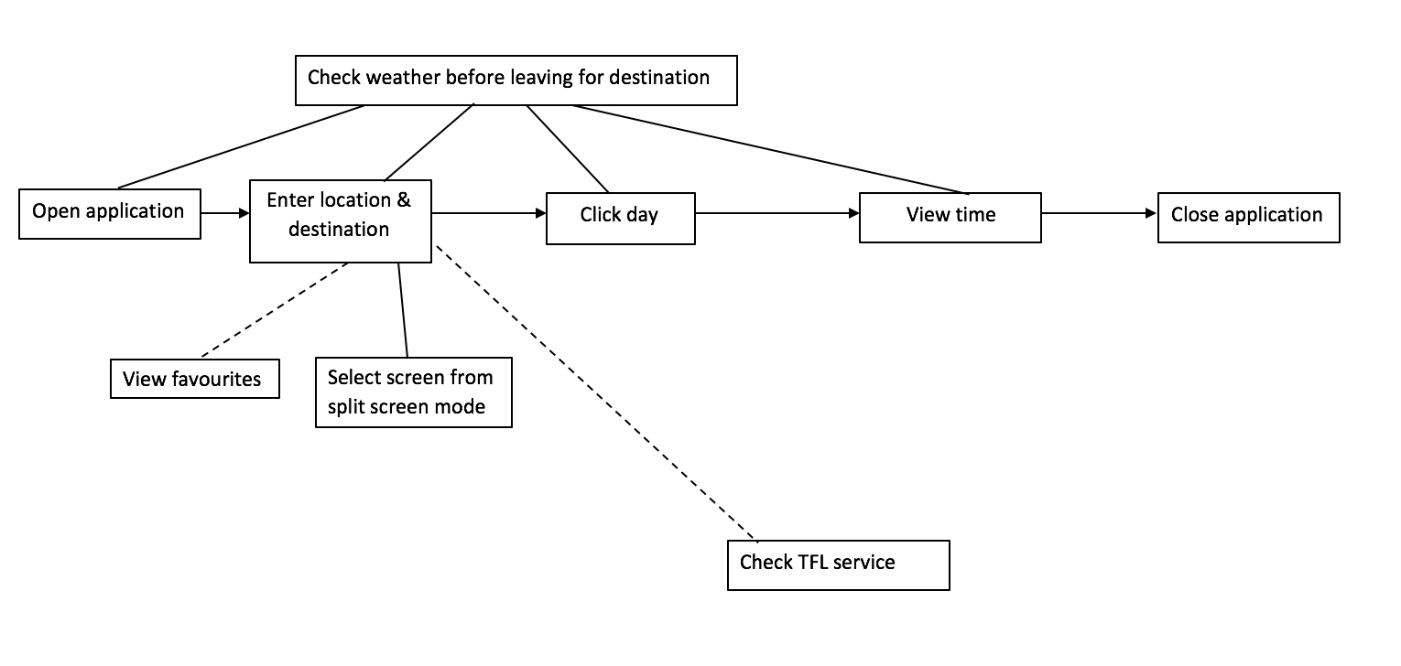

**Event Goers:**

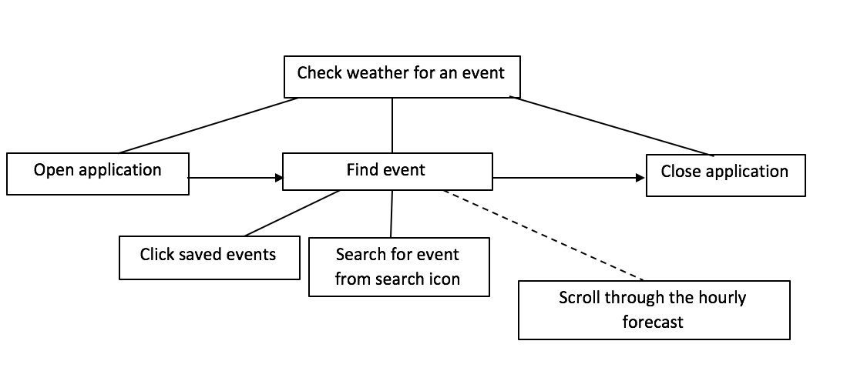

**Existing weather apps**

We have evaluated the popular weather apps BBC weather, Yahoo & The Weather Channel to understand the needs of our specific users. We assessed the pros and cons of all these apps to decide upon the features that will be valuable for our primary stakeholders.

For all the applications that we are assessing navigation around app is through touchscreen and all share a similar UI.

**BBC weather**

This is an application that is available on all platforms. The UI is simple in design and the weather information is the most accurate out of all the apps we are comparing.

Amongst the features one that was found to be popular is the hourly forecast. As users usually travel knowing the timeframe they will be out, having this feature allows them to check the weather at the exact hour they are leaving. This allows them to be prepared whatever the weather.

On the home screen there is basic information on todays weather (e.g. high & low temperature, description of weather) and clicking anywhere on todays weather will open an hourly forecast of todays weather. The user can scroll across to view a 24 hour forecast. Further by clicking on an hour a more in-depth forecast for the current hour.

You can see when the forecast was last updated giving the user reassurance that they are getting the most up-to-date information.

Also the share with friend’s feature allows the user to share a screenshot of the weather through message, email, etc.

One way to assess popularity is through reviews. From a sample we have found that for BBC Weather, the simple interface and accuracy is what makes it such a popular app. One unique feature is the weather warnings from BBC that are provided by the MET office.

****Example review:

**IOS Weather**

This app is available on the iPhone and it gets it weather data from The Weather Channel. iOS weather was found to be the most used weather app amongst our respondents.

From their responses we found that this was because it was easy to use, never crashes and a 10-day forecast is available. It also has a very simple UI and provides access to the most relevant information.

From reviews we have found that this app appeals mostly to those looking for basic, easy & quick weather information.

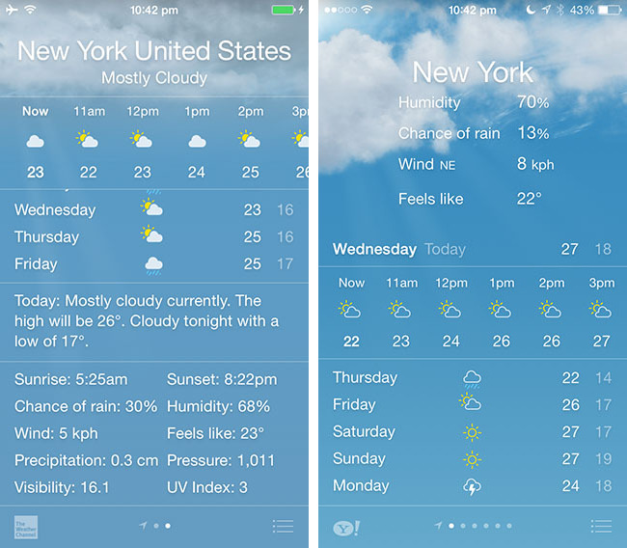

The interface

**Yahoo**

The designers aim of this app was to make checking the weather inspiring with stunning photos that matched the user’s location.

User’s can view previously saved locations by swiping across the screen. We have found this to be a popular feature amongst users.



The user navigates through the current day’s weather in their current location by scrolling down. From doing this they will be able to see in-depth information e.g. hourly forecast, precipitation, wind & pressure.

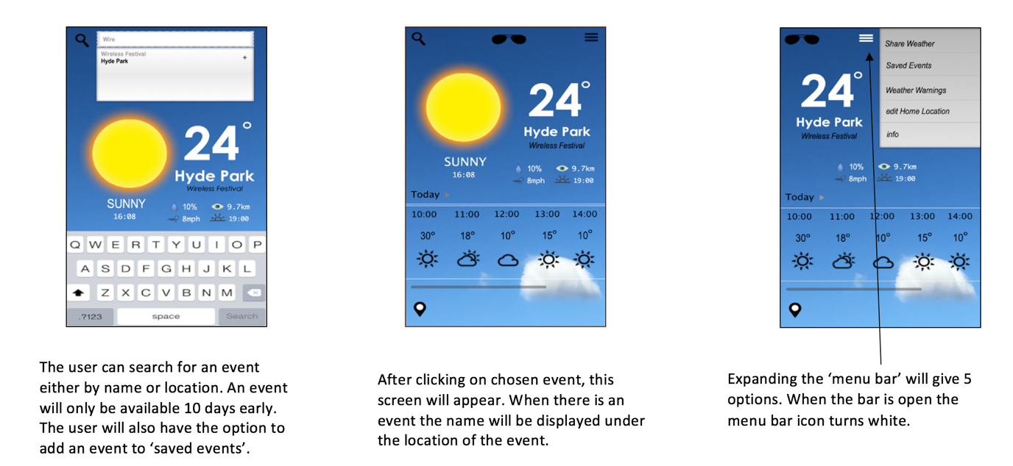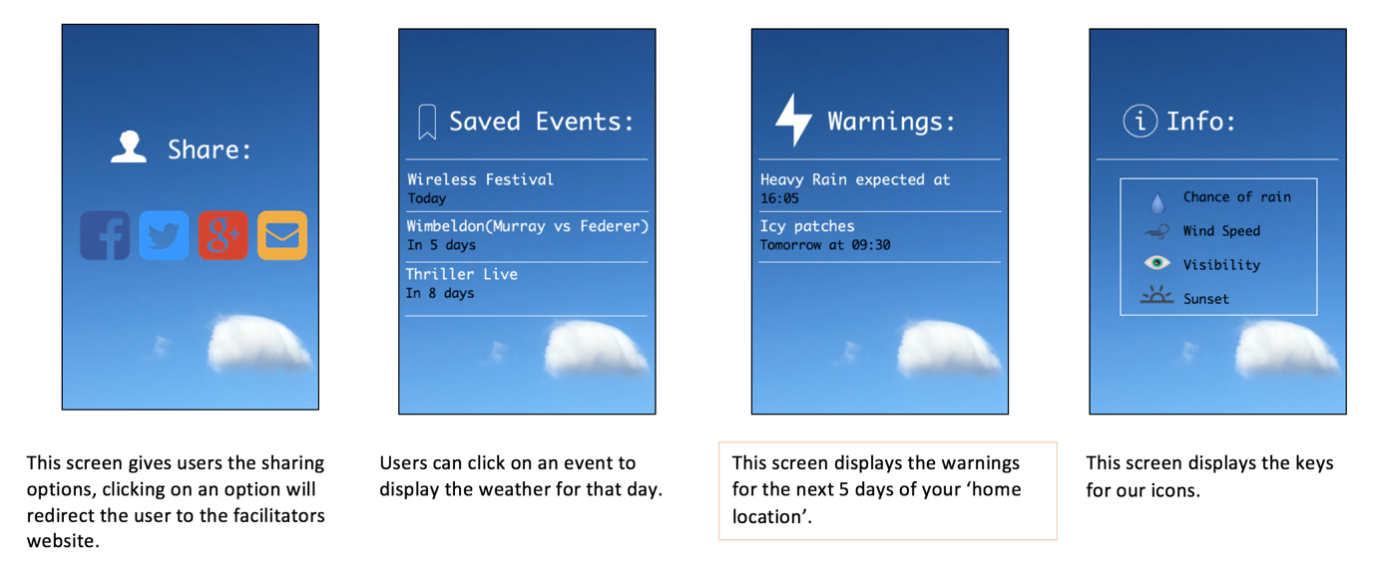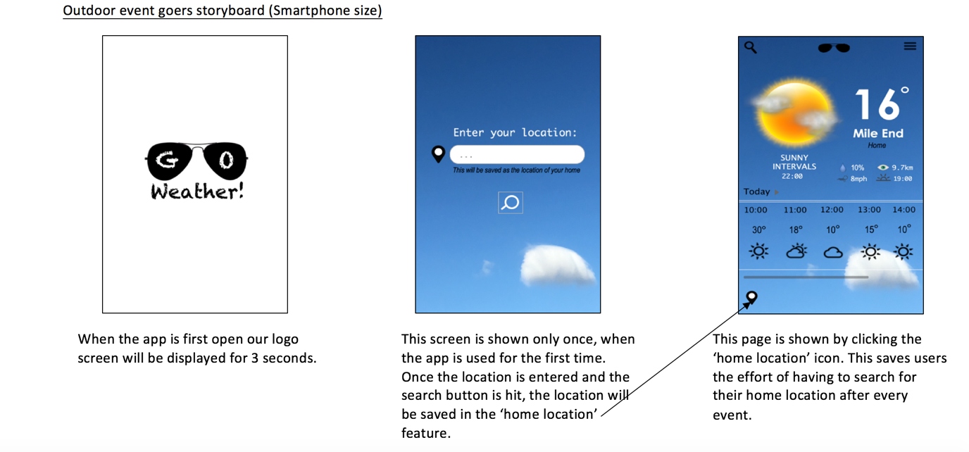**Design**

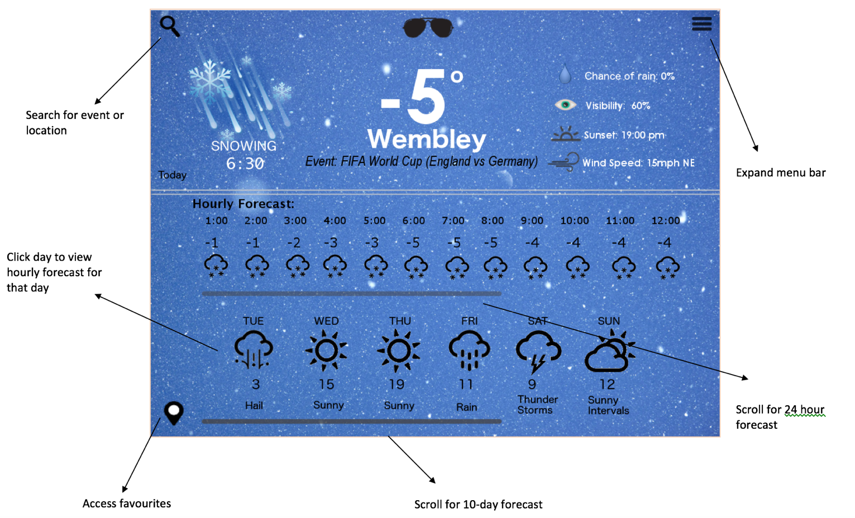Outdoor event goers storyboard(Tablet size)

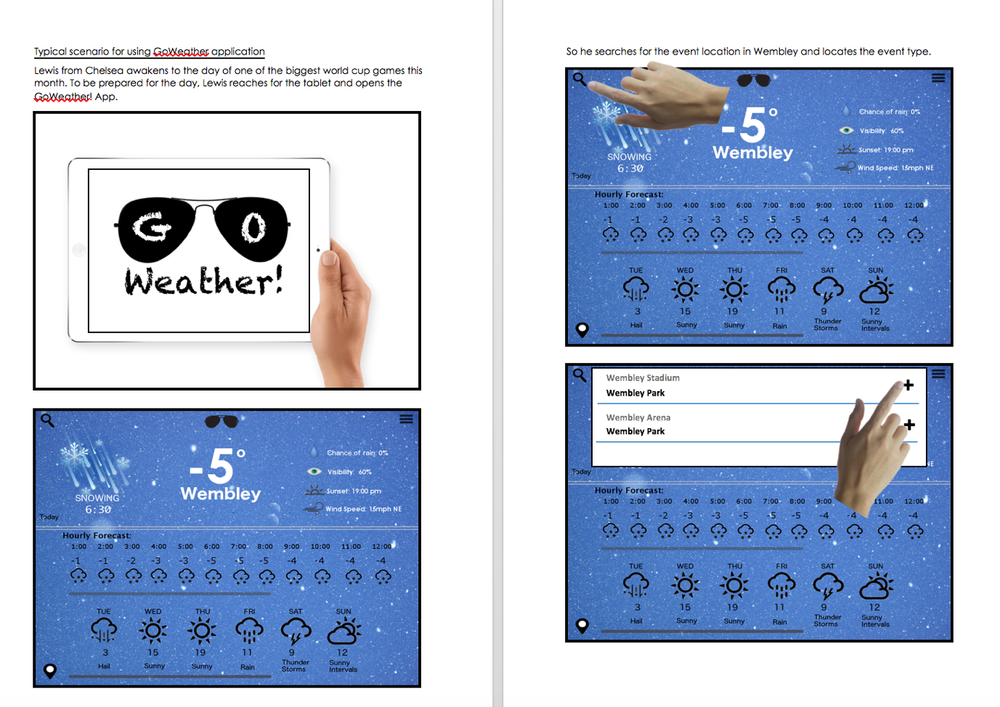

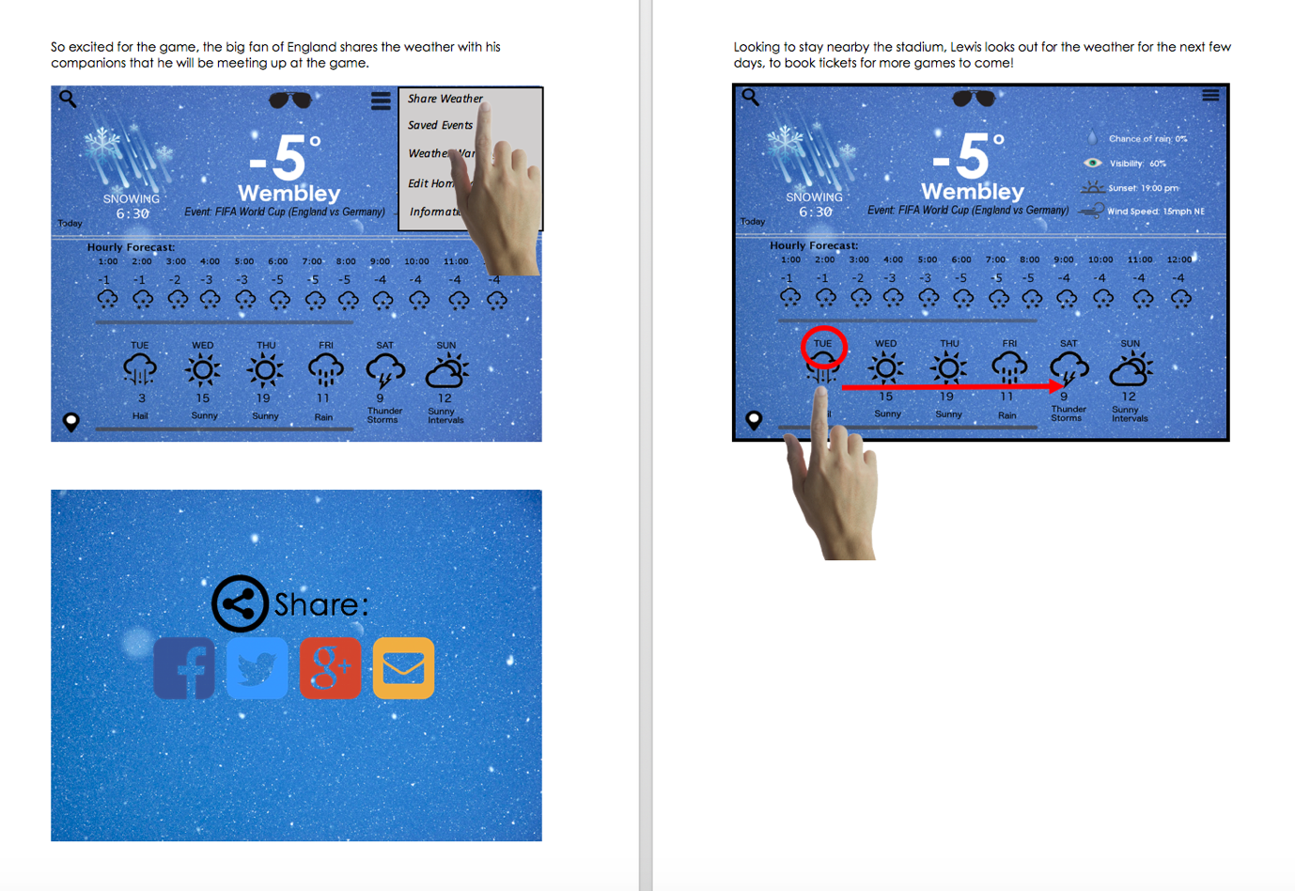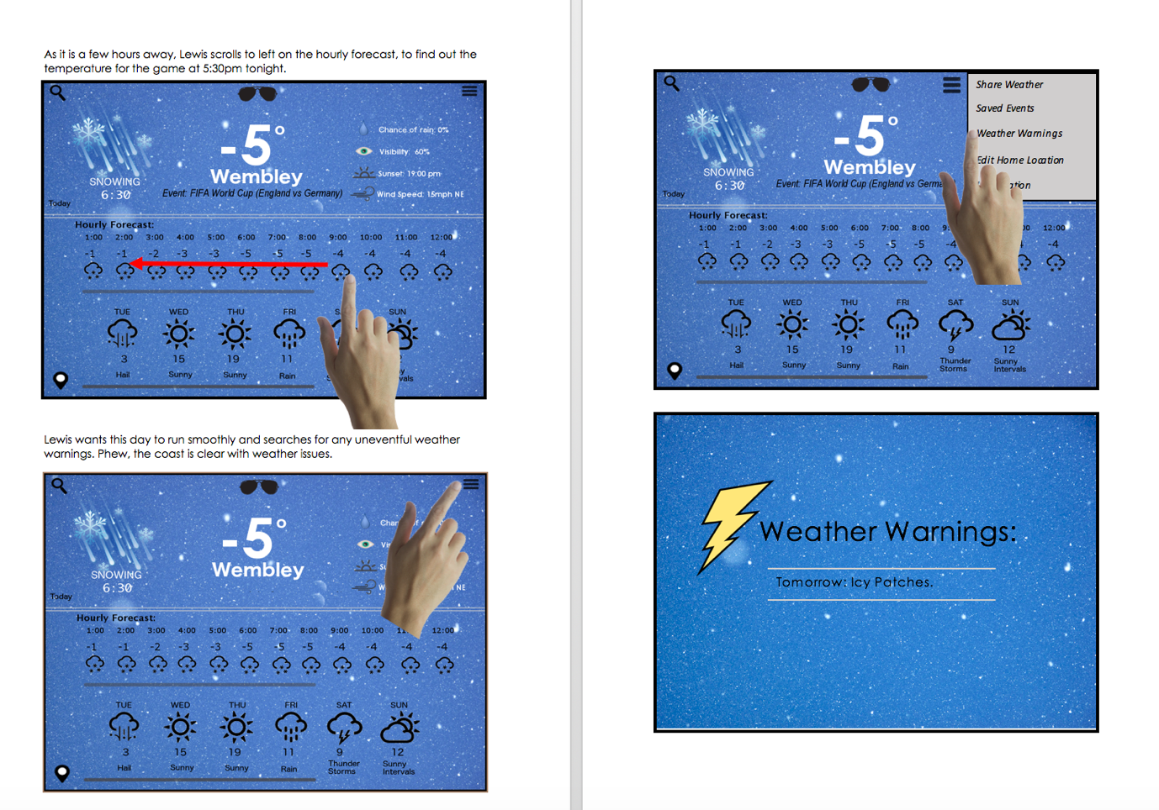

7

6

5

4

3

2

1.

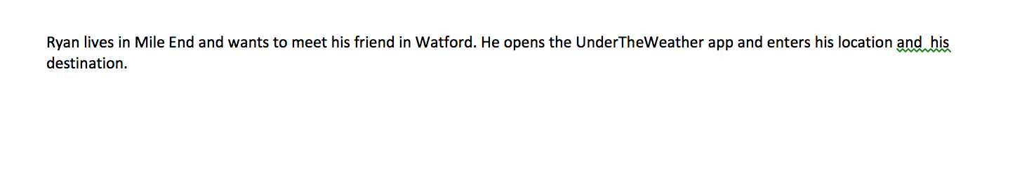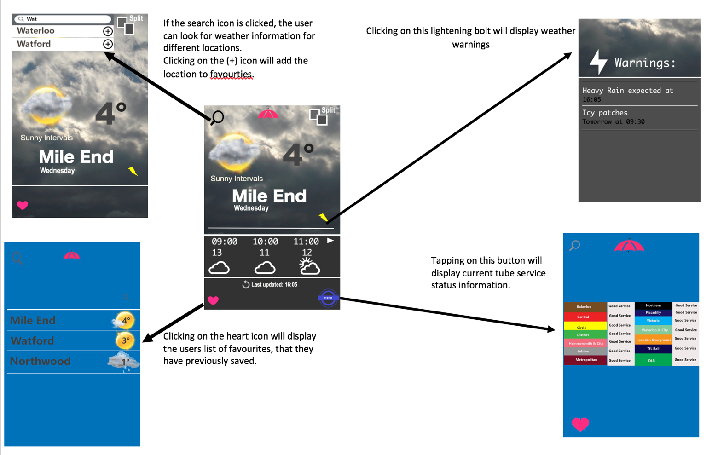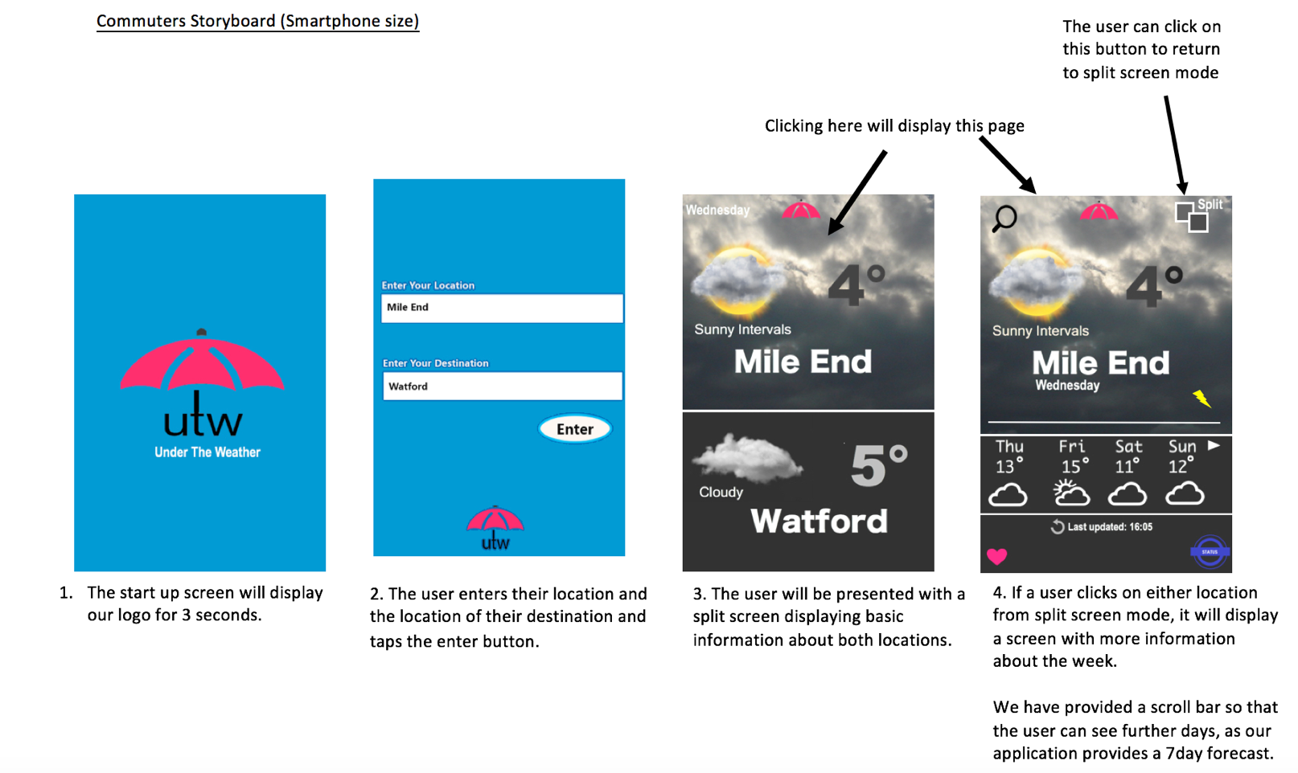

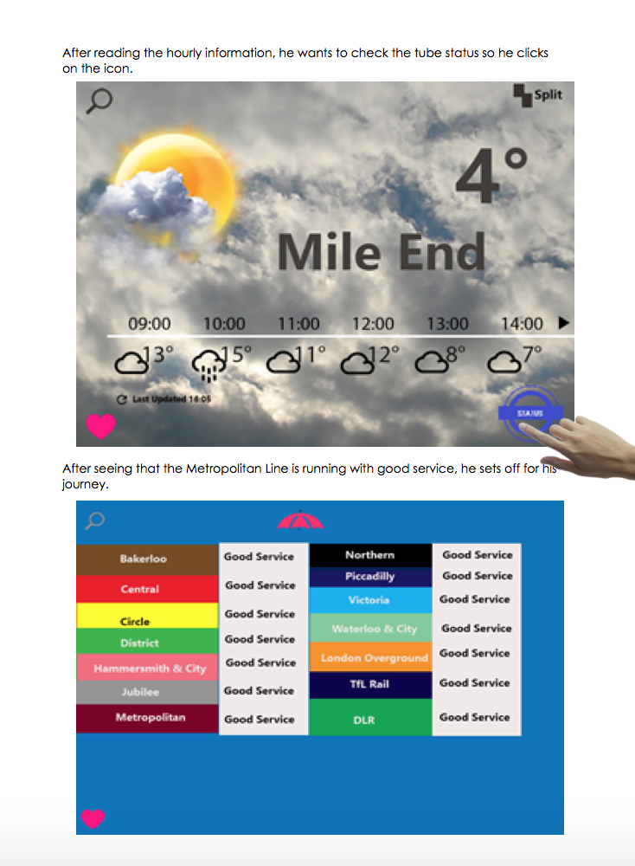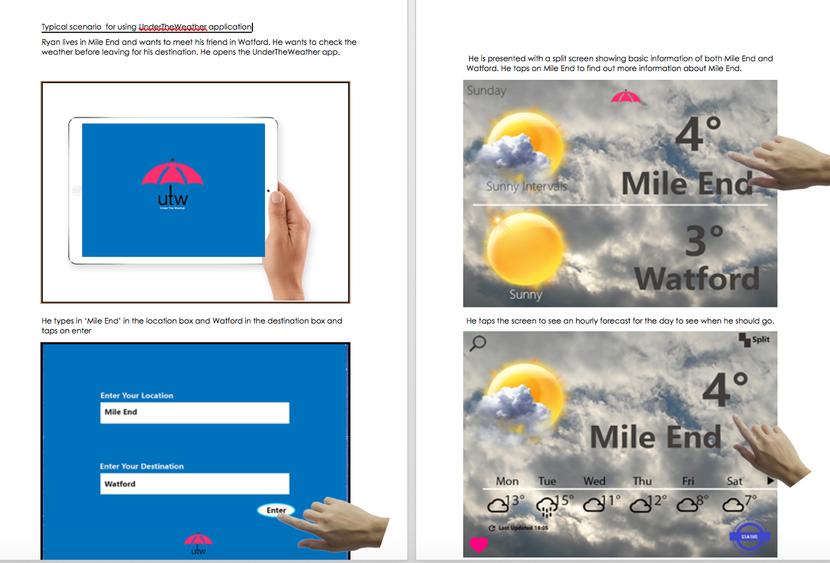

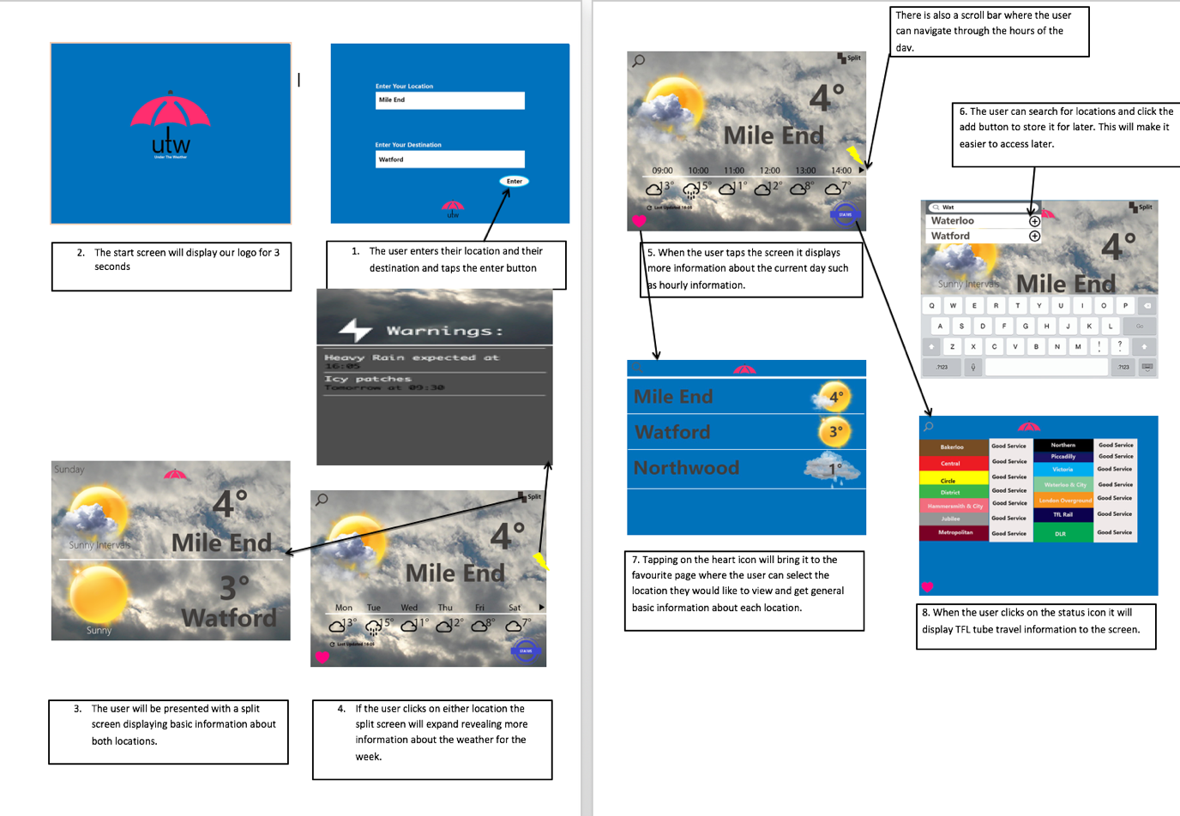

**Bibliography**

Iconfinder (2000). search icons. Available: https://www.iconfinder.com/search/?q=search. Last accessed 5th feb 2016.

R, Expert. (2001). keyboard. Available: http://www.expertreviews.co.uk/mobile-phones/1400618/48-incredible-ios-8-ipad-and-iphone-tips-tricks/page/0/1. Last accessed 3rd Feb 2016.

Niki. B (2008). weather. Available: http://poros-nikisvillage.eu/. Last accessed 31st jan 2016.

Graham Bauckham. (2011). WATCHING THE CLOUDS GO BY….Available: http://varsitytents.com/watching-the-clouds-go-by/. Last accessed 31st jan 2016.

Index of /y27/images. (2008).  Available: http://www.vivo.co.th/y27/images/. Last accessed 31st jan 2016.

Rahman, J. (2008). 12 Stylish Beautiful Blogger/Blogspot Search Box.Available: http://www.codiblog.com/2016/01/blogger-search-box.html. Last accessed 31st jan 2016.

365webresources. (2015). 15+ Weather Icon Sets You Shouldn’t Miss.Available: https://365webresources.com/15-weather-icon-sets-shouldnt-miss/. Last accessed 31st jan 2016.

Cliparts. (2016) Available: http://cliparts.co/clipart/2492979. Last accessed 3rd feb 2016.

Clipart panda. (2014). 60 images for Location Icon Map Png. Available: http://www.clipartpanda.com/categories/location-icon-map-png. Last accessed 3rd feb 2016.